Non-Examined Assessment (NEA)

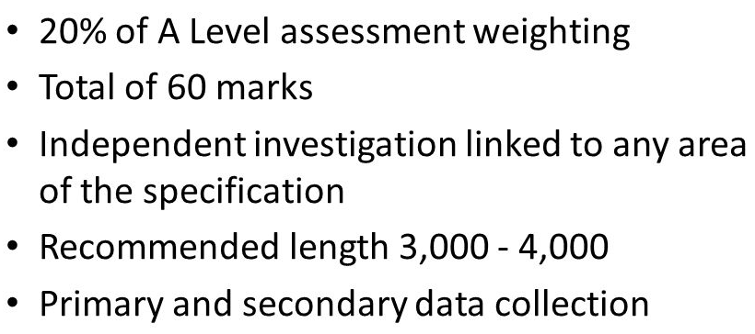

Timings and deadlines (2020):

5/6th May Introduction to the NEA – begin planning, introduction and research.

Summer Fieldwork / data collection

DEADLINES:

26th June Planning, purpose and introduction

14th September Data, information collection methods and sampling framework

28th September Data presentation

5th October Data Analysis and explanation

12th October Conclusions and investigation evaluation

5th November Submission of draft NEA

30th November Final submission of NEA

1. The Non-Examined Assessment (NEA)

The independent investigation:

• Is linked to any area of the specification. This can include topics that are options which you are not studying, although that would be unusual and carries a risk as you may be less familiar with the topic content. You could link more than one topic for example coastal management and place or hazards and place, this will depend on your chosen title.

• Recommended: 3,000 - 4,000 words. You will not be penalised for exceeding the recommended length; however, work that significantly differs from the recommended length might be self-penalising. The ability to write succinctly (keeping to the word length), making points sharp and focused especially in the analysis and conclusion will help the reader (your teacher) navigate their way through.

• Includes primary and secondary data collection. Note that there does not need to be a balance of primary and secondary, it will depend on the nature of the topic under investigation.

The NEA is scored out of 60 and is worth 20% of the final A-level.

There are lots of ideas to help you decide on a study area which are detailed on the blog. The NEA is an independent investigation, although you can collect in groups.

You should use some of the following specialised concepts to underpin the investigation:

- Adaptation  - Causality  - Equilibrium  - Feedback  - Globalisation  - Identity  - Inequality  - Identity | - Interdependence  - Mitigation  - Representation  - Resilience  - Risk  - Sustainability  - Systems  - Thresholds

2. Choosing a title

It is important to remember that your NEA must investigate a question or an issue about something to do with the OCR geography specification.

Experience has shown that the most straight forward investigations are those which:

- study some form of human issue, which involves people's perceptions and opinions OR a physical investigation exploring links and correlations.
- must relate to ideas studied in lessons (in your textbook) and use precise geographical terms (e.g. structural economic change, deprivation, emotional attachment to place, social inequality).
- Refers to the ‘specialised concepts.

It is generally easier to base your enquiry on issues relating to settlement i.e. place, deprivation, transport or housing, although you can study changes in physical systems that relate to glaciation, coasts or carbon and water cycles.

3. How the NEA is assessed

Planning, purpose and introduction (8 marks)

Clear, well focussed plan with aims / hypotheses
Individual geographic topic or issue
Justification and contextualisation of research
Location is precise using geo-spatial techniques
Valid and individual literature research
Wider geographical links, comparisons, models and theory

Data, information collection methods and sampling framework (7 marks)

Wide range of data collection methods which are justified in their use
Quantitative techniques
Qualitative techniques
Personalised methods
Digital and geo-located data
Sampling is appropriate and justified
Justification of location choice
Demonstrates understanding of ethical and socio-political dimensions of methods.

Data Presentation techniques (9 marks)

Appropriate and selective presentation
Wide range of techniques (>6)
Use of both simple and more sophisticated techniques (e.g. cartographic)

Data Analysis and explanation (14 marks)

Data and information is analysed and interpreted, showing independence
Use of statistical analysis and significance testing
Use of qualitative (non-numerical) analysis techniques
Analysis and explanation is relevant and links to aims / hypotheses
Effective use of knowledge, theory and concepts

Conclusions and investigation evaluation (12 marks)

Thorough conclusions which link to aims / hypotheses
Very well argued case which draws on primary and secondary evidence
Evidence that geographical understanding has been extended
Strong evaluation including reliability of sources and data collection methods (representation of sampling technique is clear)
Understanding of ethical and socio-political dimensions of research and presentation

Overall quality and communication of written work (10 marks)

Clear arguments; individuality; structured; logical; integrated; concise; referenced sources; technical terminology; high standard of communication

4. Introduction (500 - 750 words)

- After stating your title clearly, briefly say why you have chosen it. Complete the planning sheet in detail to show a clear, well focussed plan.
- Clearly define your topic or issue; explain your aim; what do you hope to achieve?
- Justify the investigation: why is it relevant? How can this help geographical understanding? How does it link into the specification?
- Describe where you are going to do it. LOCATE YOUR STUDY AREA – A ‘cascade’ of maps from the national down to the local scale is a good idea. Don't forget a title, north-point, scale and key. You must discuss the significance of any maps in your introduction i.e. main transport routes being important for access to a superstore.
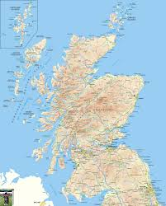
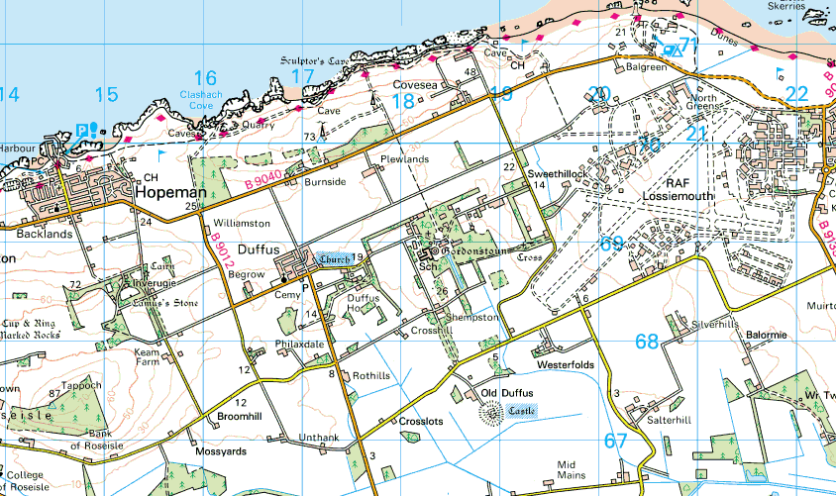
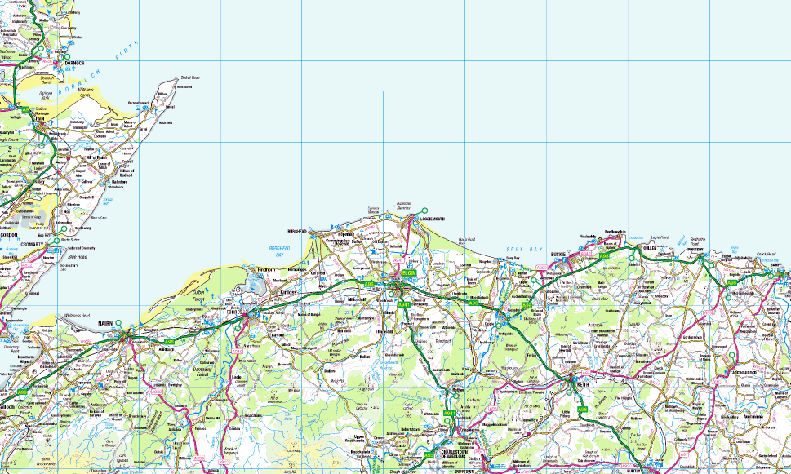
Gordonstoun

Moray

Scotland

- Literature research: A detailed literature research should be evident which defines and contextualises the investigation. Refer to models, theories and geographical links; compare with other areas (similar or contrasting); use careful internet research to back up you hypotheses.

Literature Research:

The literature research must be undertaken at the start of the enquiry process as it provides several vital functions, helping to ‘situate’ your independent investigation:

- Theoretical literature about the topic of your study. This gives a context and helps you to understand the background to the urban topic, including any models or ideas that underpin understanding.

- Design and methodologies literature. This helps you to plan and design your fieldwork and research and how to select and to use the methods you choose. Don’t be afraid of borrowing approaches and ideas from other published studies.

- Empirical (experimental and study) literature. This might be previous research in your topic area which gives opportunities to contextualise and compare your findings to published research. This can give additional ideas around how and why your investigation produces either similar or different outcomes.

Aims and Hypotheses

You need to state clearly the main aims of your investigation i.e. what you intend to find out and how you will do it. This should consist of one main aim (consisting of a single sentence that could be similar to your title e.g. AIM: To investigate the correlation between deprivation and environmental quality in Inverness

Your hypotheses (maximum 5) are predictions of what you think you will find out in the study i.e. what your results will show – explain how you have come about these predictions.
e.g. Areas with a lower environmental quality will have high levels of deprivation.

Your hypotheses must be related to your main aim and they are often inter-linked to one another

5. Methodology (750 - 1000 words)

Think about how you are going to present and analyse your data…
- You must use a range of data collection methodologies (around 6) which include suitable quantitative and qualitative approaches. These must be justified and explained in detail
- There must be evidence of a personalised approach – methods that you have made up and / or are individual to you.
- You must use primary and secondary data collection methods.
- Use digital and geo-located data (data from a map i.e. SIMD maps)
- Sampling technique needs to be clear and justified: systematic, random and/or stratified. How did you obtain a representative sample and avoid bias (e.g. age, sex, type of weather)?
- Explain when, where, how and why each method has been collected.
- Address the ethical and socio-political considerations that have allowed for in your data collection process (i.e. asked before taking photographs, gained permission before using sensitive data, asked questions that do not cause offense etc).

Method

- Introduction to methods - where did you collect the data and why?

- List methods: (example):

- Method 1:
    - What and how I collected data?
    - Where I collected the data and why? use a map…
    - Sampling technique - systematic, random or stratified - how is my sample representative?
    - Ethical, socio-political considerations (see above and page 16)
- Method 2:
    - as above…
- Method 3:
    - as above…

Try to use as much ORIGINALITY, INITIATIVE and VARIETY as you possibly can…
Here are some methods of collecting data that you could use for a human investigation:
- Questionnaire – min 30 max 100 (https://survey123.arcgis.com/)
    - - Survey monkey / Google forms / Instagram / Trip Advisor
- Land use survey / Housing survey
- Environmental Quality Assessment (EQA)
- Sound survey (decibels)
- Traffic count
- Pedestrian count
- Interview - Use zoom
- Bus times
- Drive times
- Photographs
You must also use Secondary sources to gain information
- newspapers
- libraries and museums
- Census data
- Internet sites (see link on the blog)
- GIS
- Newspaper property sections
- Tourist information, citizens advice bureau

6. Presentation of data

You will get most credit if you follow the following guidelines:

- Use a variety of appropriate techniques to show your results. You might want to start by including a table containing all your results, then presenting relevant data in diagrams, graphs or maps.
- Be selective! You do not need a bar chart, pie chart, table and line graph to represent the response for every question in a questionnaire! One of each type is sufficient. DO NOT represent the same data differently.
- You must employ more advanced skills when presenting your data, especially geo-located data (data on a map). Don't just draw lots of pie charts that do not show a high level of skill.
- Clearly label each illustration with a number (e.g. fig.1), a title and other labels relevant to the individual example (e.g. scale, axis labelling etc.).
- You may include photographs in your data section, but make sure they are there for a purpose and you must annotate them.
- Secondary Data is also very important. Only extract relevant parts to include in this section. This could be in the form of quotations or text (this can be represented on a map and coded)

You will need to include AT LEAST 6 different ways of presenting the data

Finally only include data that is analysed and interpreted in the next section.

The following is a list of some techniques you can use: you are not expected to use them all, just a small selection!

Techniques of presentation and statistical analysis

Maps Remember
- Sketch Maps
- Land Use Maps (colour-coded) Orientation
- Choropleth (or density shading) maps Key
- Isoline Maps (join points of equal value) Scale
- Flowline Maps (shows volume of movement) Title
- Proportional Symbols (i.e. circles - pie charts
where different sizes can illustrate variables
such as population.
- Desire lines (shows sphere of influence)

Graphs Remember
- Bar Charts
- Histograms (frequency bar graphs) Label Axes
- Pie Charts Title
- Scatter graphs (including best fit line) Key
- Line Graphs (may include logarithmic scales)
- Cross-sections
- Triangular Graphs
- Cumulative frequency graphs

Other
- Tables of results
- Field Sketches – with labels
- Photographs – annotated or with labelled tracing - paper overlays
- Transects

Statistics
- Averages: mean (average), median (middle) and mode (largest frequency)
- Inter-quartile range, standard deviation
- Chi Squared
- Spearman's Rank Correlation Coefficient (indicates whether there is any similarity between two different variables)
- T-test
- Mann Whitney
- Cumulative Rank Correlation (percentage graph)

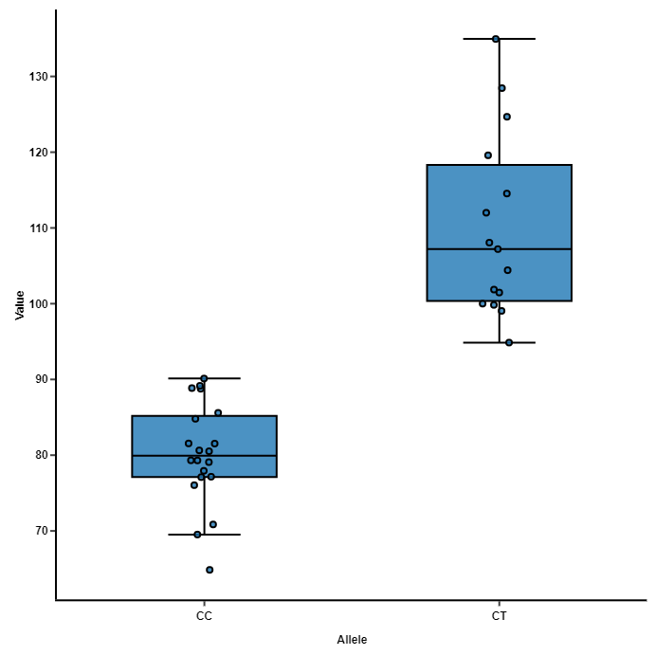

A Scatter plot, using a box and whiskers to illustrate range and IQR. This distribution can then be analysed using Mann Whitney to determine how confident you can be that there is a significant difference between site A and B.

7. Data Analysis and Interpretation
This section should be inter-linked with the presentation (1000 - 1250 words)

This section is worth 14 marks and therefore time should be spent completing this effectively and coherently.

Essentially you will discuss your hypotheses, and explain whether they were correct or not; then explain why this is the case:

- Describe what your graphs and presentations show (number them so you can easily refer to the graphs etc.) Give highest and lowest figures and state anomalies. You must manipulate your data.

- Explain what your presentations show using geographical terminology throughout.

Both the description and explanation should be written under each graph.

- Demonstrate knowledge and understanding by linking to your wider geographical reading

- Use statistical analysis and significance testing. You will need to have collected data (numbers or text that can be coded). For more advanced statistics you need to be able to draw a scatter graph or a scatter plot – any statistics must be relevant to the investigation

- Qualitative / non-numerical analysis must be developed. This should be in the form of extended writing and help to prove / disprove you hypotheses.

- Regularly link all your analysis directly to your aim and hypotheses

- Link to geographical theory and the specialised concepts.

8. Conclusions
Conclusion and evaluation should be 750 - 1000 words
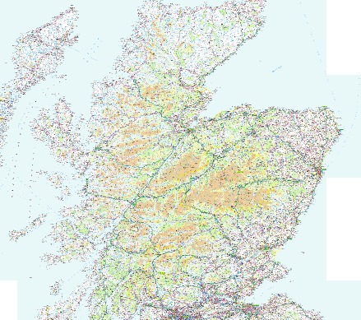
- State each hypothesis and say whether it has been proved or disproved.

- State which graphs, maps etc. prove or disprove your hypotheses and why…

- Use the word link…! i.e. …THIS IS LINKED TO… - You must link data that proves / disproves the same hypothesis.

A good way of finding links between the data is to draw a table and explain what it shows:

 | Graph 1 | Graph 2 | Graph 3 | Graph 4
Hyp 1 |  | ❒ |  | ❒
Hyp2 |  |  |  | 
Hyp 3
Hyp 4
Hyp 5

Conclusions must:

- be clear and accurate
- link to aims / hypotheses
- be communicated by means of extended writing
- draw effectively on primary and secondary evidence
- link to theory / research to provide a well-argued case

9. Evaluation

You must convince the examiner that by conducting this investigation you have extended geographical understanding.
This should be written under three headings:

- Evaluation of methods

What are the main limitations / problems of your investigation? Comment on the deficiencies of the methods used (i.e. accuracy of sampling technique, problems with bias, larger sample needed, different times/days) and explain why they are deficiencies.

Try and answer the following questions:
- Did I collect enough data – NOT just a simple yes or no?
- What are the disadvantages of the techniques of data collection that I used?
- Would my results be of a better quality if I had collected more data/different data/data at a different time/data with a different method – consider the sample technique you used.
- If I did a similar study in the future how would I improve my methodology and justify WHY it would be better.
- How could I improve the reliability of my methods and so improve my investigation.

- Evaluation of results

You must describe how your investigation could be improved by questioning how the reliability of the methods you used to collect data have affected the ACCURACY of your RESULTS…
Try and answer the following questions:
- How accurate are my results e.g. does some data contradict your other findings?
- Would the results be different if I collected the data in a different place/time?
- Is there a link between inaccuracy and problems with my methods?
- Have I clearly identified which results support my hypotheses? Have I given reasons for this?
- Have I clearly identified which results don’t support my hypotheses and given reasons for this mismatch?
- Have I stated the improvements that could be made to my investigation in order to increase the accuracy of its results?

- Evaluation of conclusions

You must describe how your investigation could be improved by questioning how the reliability of the methods you used to collect data have affected the accuracy of your results and the VALIDITY of your CONCLUSIONS.

You should try to answer the following questions:
- Have I related my conclusions to my original hypotheses?
- Have I explained why my conclusions might not be applied to other parts of the UK?
- Have I explained why my conclusions might be invalid or wrong?
- Have I tried to link any weaknesses in my conclusions to the results or methodology?
- What improvements could I make to my investigation to increase the validity of my conclusions?

- Ethical and socio-political dimension

You must show that you have considered the ethical and socio-political dimensions of field research and presentation. This is particularly relevant where you have visited areas where people live and work; you have used photographs for presentation; or used quotes from questionnaires / interviews.

It's not just anonymity that is an issue in making participants feel comfortable. You should consider their position in relation to their participants. For example their own age, gender, socioeconomic status, culture, religion, skin colour, role, even their accent in relation to their participant, will all have an impact on how their participant responds.
For example if you are asking about views on migration, the ethnicity of the student and the participants might influence their answers.
If you are asking other students in lower year groups, the participants might respond in a certain way based on their assumption that an A-level student knows more than them, eg they might feel a little intimidated or as in the are being tested. Similarly, of they are questioning someone who knows nothing about Geography or a member of the public who did not do very well in school themselves.
You would therefore start the interview by reassuring them that it's not a test; any answer is valid and if they can't think of an answer they can just say they don't know.
If you are interviewing someone older/in a higher position, they could also influence the answers. The person might feel like they should make up some extra stuff to help the you out and give more to write about on the project for example. Or, they might not want to be fully honest with the student.
You need to consider in advance what to do of the participant expresses an over offensive view (eg racist or sexist) or what to do if the respondent discloses sensitive information especially to do with crime and especially if it was another student in the school for example.

10. Literature referencing

You must reference sources of data and any literature that you have used throughout the investigation. This is should be done by briefly referencing in the body of the report when it has been used, then in detail in a bibliography at the end of the project. The following is an example of the ‘Harvard’ style referencing:

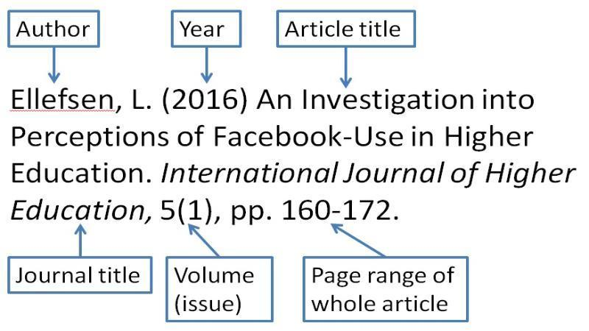

11. PROJECT STRUCTURE
This is the order in which your completed coursework should be organized and written up.
CONTENTS PAGE

1) INTRODUCTION

- AIMS

- HYPOTHESES

- CONTEXT OF LITERATURE RESEARCH

2) METHODS OF DATA COLLECTION

3) ANALYSIS AND PRESENTATION OF DATA

4) CONCLUSIONS

5) EVALUATION

6) BIBLIOGRAPHY (REFERENCES)

